Sheet #2 - Using Functions and HTML Event Handlers

Exercise: (exercise derived and modified from Gosselin text)

In this exercise, you will use an event landler to automatically fill text boxes in a form with preassigned values based on the option button that a user clicks.

The HTML page named index.html containing the form is available to you as a starting point (See Lea).

Edit index.htm in a way that if you click **Home** option button, the Street Address, State, and Zip fields should be filled with the information shown beneath the word “Home” as shown in figure 1. If you click **Work** option button, the Street Address, State, and Zip fields should be filled with the information shown beneath the word “Work”.

In order to do this, each radio button will need a click event to call a function which automatically fills text boxes in the form with preassigned values.

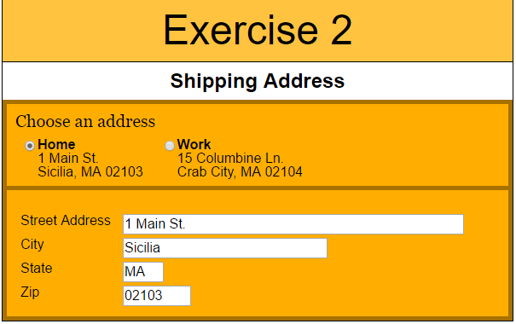

Figure 1: Fields populated with home address info

Get your page checked off when done.